EN
NTx Serum
NTx9021
96

Institute Name | Date
PRINCIPLE OF THE ASSAY
The NTx Serum assay is a competitive-inhibition enzyme-linked immunosorbent assay (ELISA/EIA) for quantitative determination of NTx in human serum. NTx epitope is adsorbed onto a 96-well microplate. Diluted samples are added to the microplate wells, followed by a horseradish peroxidase labeled monoclonal antibody. NTx in the patient sample competes with the NTx epitope in the microplate well for antibody binding sites. Following a wash step, the amount of labeled antibody bound is measured by colorimetric generation of a peroxide substrate. Absorbance is determined spectrophotometrically and NTx concentration calculated using a standard calibration curve. Assay values are reported in nanomoles Bone Collagen Equivalents per liter (nM BCE).
TEST SYSTEM COMPONENTS
Kit Component |  | Quantity  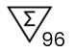 | Description
A |  | 1 Plate | Antigen coated 96-microwell plate. 12 x 8-well strips coated with synthetic NTx antigen.
B |  | 40 mL bottle | Specimen Diluent. Buffered reagent into which calibrators, controls and specimens are diluted. ProClin™ 300 (0.05%) included as a preservative.
C |  | 0.4 mL vial | Antibody Conjugate Concentrate. Solution containing purified mSerum monoclonal antibody directed against NTx conjugated to horse radish peroxidase and Proclin™ 300 (0.1%). Supplied as a 100X concentrated conjugate.
D |  | 25 mL bottle | Antibody Conjugate Diluent. Buffered reagent with protein stabilizers, into which Antibody Conjugate Concentrate is diluted. ProClin™ 300 (0.05%) included as a preservative.
E |  | 0.9 mL bottle | Chromogen Reagent. One vial containing a solution of 3,3’,5,5’ – tetramethylbenzidine in dimethyl-sulfoxide. Supplied as a 100x concentrate.
F |  | 30 mL bottle | Buffered Substrate. One bottle containing a buffered hydrogen peroxide solution.
G |  | 25 mL bottle | Stopping Reagent. One bottle containing a solution of 1N sulfuric acid.
H |  | 125 mL bottle | 30X Wash Buffer Solution. One bottle containing a 30X ionic detergent solution.
0 |  | 20 mL vial | 0 nM BCE Calibrator | Various amounts of purified NTx antigen in stabilized protein diluent. Contains ProClin™ 300 (0.05%) as a preservative.
5 |  | 0.4 mL vial | 5 nM BCE Calibrator
10 |  | 0.4 mL vial | 10 nM BCE Calibrator
20 |  | 0.4 mL vial | 20 nM BCE Calibrator
40 |  | 0.4 mL vial | 40 nM BCE Calibrator
I |  | 0.4 mL vial | Level I Serum Control | Human serum material with known NTx concentration. ProClin™ 300 (0.10%) included as a preservative.
II |  | 0.4 mL vial | Level II Serum Control
 | Plate Sealers | 1 Pad | Plate Sealers
NOTE: Note: Bovine Serum or Bovine Serum Albumin is present in some components
MATERIALS REQUIRED BUT NOT PROVIDED
- Single and multichannel pipettes capable of delivering 25 μL, 100 μL and 200 μL volumes.
- Disposable pipet tips.
- Disposable plastic containers for reagent mixing and pipetting reservoirs.
- Automated microwell washer.
- Microwell or microstrip spectrophotometric reader. The reader must read at 450 nm with a 630 nm reference filter and detect absorbances from 0 to 3.000 (or greater) optical density units.
- Software capable of calculating a 4-parameter curve fit.
- Deionized water.
- Microtubes or equivalent.
STORAGE CONDITIONS
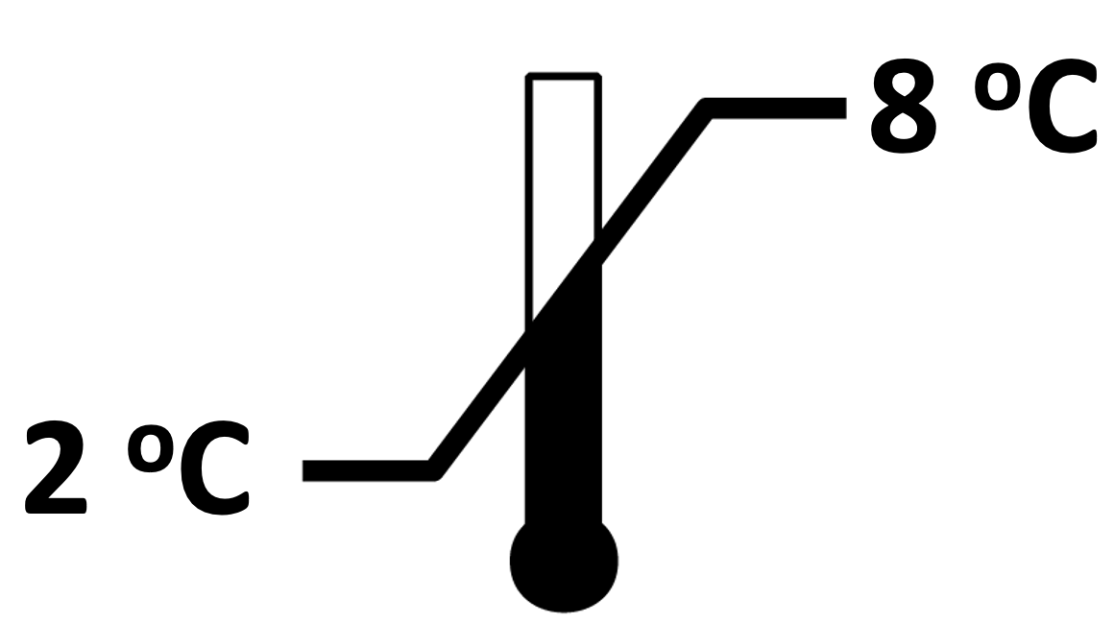 | When not in use, the kit should be stored at 2 – 8 °C. Reagents must be allowed to reach room temperature before use. Do not expose the reagents to temperatures greater than 30 °C or less than 2 °C.
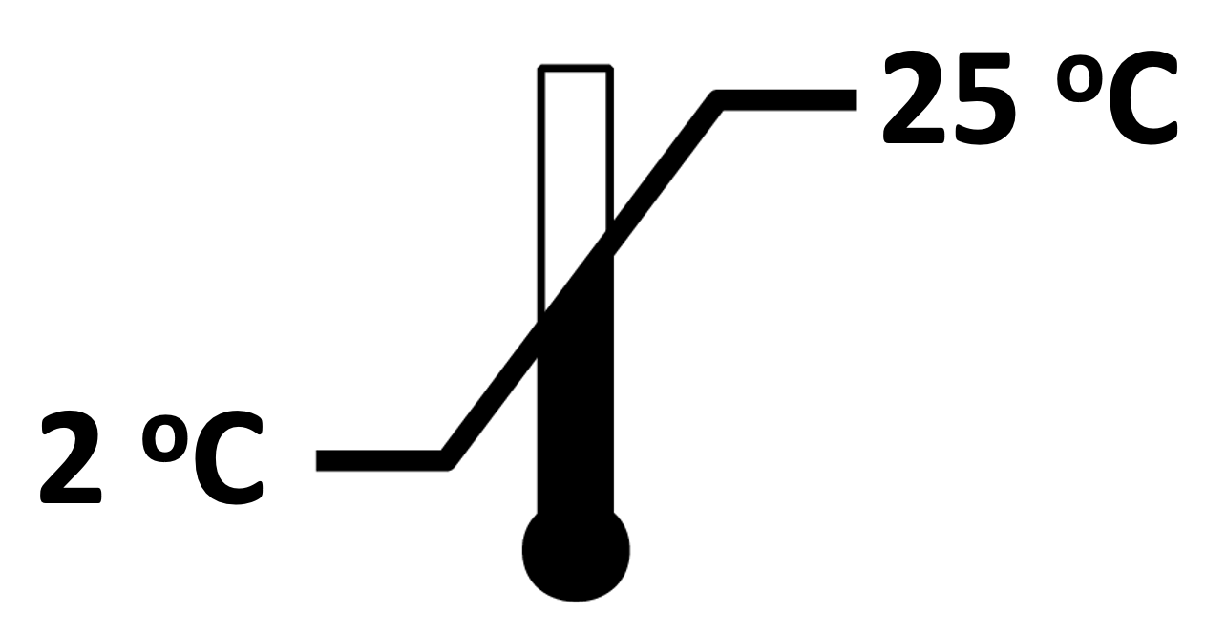 | Diluted (1X) wash solution may be stored at room temperature for up to one month.
PRECAUTIONS
- For in vitro diagnostic use only.
- The Calibrators and Serum Controls contain process antigen from human bone tissue and/or human sera. Although each lot has been documented to be non-reactive for HIV 1, HIV 2, HBsAg, HCV and RPR by FDA approved methods, these materials should be handled as potentially infectious and should be disposed of properly.
- The Stopping Reagent contains 1N sulfuric acid. Danger: Causes severe skin burns and eye damage.
- The Chromogen Reagent contains 3,3',5,5'- tetramethylbenzidine and dimethylsulfoxide. Warning - Dimethylsulfoxide is readily absorbed through the skin. May cause skin irritation or serious eye irritation.
- ProClin is included as a preservative in most reagents, at concentrations listed in the reagent section. May cause skin irritation or serious eye irritation.
- The Serum Controls: Contain materials of human origin.
- Serum specimens may contain infectious agents and should be disposed of properly. Decontamination is most effectively accomplished with a 0.5% solution of sodium hypochlorite (1:10 dilution of household bleach) or by autoclaving one hour at 121 °C. Do not autoclave solutions containing sodium hypochlorite. Do not combine sodium hypochlorite solution with acid.
- Never pipette reagents or clinical specimens by mouth.
- Wear protective gloves and clothing when handling specimens and reagents. Wash hands thoroughly after use.
- Do not use reagents beyond their expiration dates.
- Do not mix components from different lots of the NTx Serum assay kits.
- Microwell strips must be kept desiccated. Reseal unused microwell strips in the pouch containing desiccant.
- Do not reuse microwells. Dispose of properly after use.
- Perform the assay procedure in a controlled laboratory environment that adheres to the stated incubation requirements. Avoid extreme environmental conditions during the procedure.

Note: Safety data sheets are available for professional users upon request.
SPECIMEN COLLECTION AND STORAGE
- Human serum collected by standard venipuncture technique is used in the NTx Serum assay. The use of plasma samples has not been established. Allow blood to fully clot and remove the serum from the red blood cells promptly. Specimens collected in serum separation tubes should be removed from the gel. Store serum samples refrigerated (2 – 8 ºC) for up to 24 hours, or store frozen (-20 ºC or below) for longer term storage. Specimens may undergo three freeze/ thaw cycles.
- For monitoring therapy, baseline samples should be collected just prior to or on the day of therapy initiation. Subsequent specimens for comparison should be collected at approximately the same time of day as the baseline specimen.
ASSAY PROCEDURE
Preparatory Steps
- Allow all specimens and reagents to equilibrate to room temperature (18 – 28 °C) for at least one hour before performing the assay. To facilitate warming, remove reagents from the kit box. Frozen serum specimens may be thawed at 37 °C, in either a water bath or an incubator, then brought to room temperature prior to use in the assay. The Chromogen Reagent contains dimethylsulfoxide, which may solidify when refrigerated but is liquid at room temperature.
- Prepare working strength wash solution. Dilute 30X Wash Concentrate 1:30 with deionized water (1 part 30X Wash Concentrate with 29 parts deionized water; example dilution would be 30 mL Wash Concentrate plus 870 mL deionized water) and mix for a minimum of five (5) minutes. The diluted wash solution is stable for one (1) month at room temperature.
- Create a plate map indicating location of calibrators, controls and serum specimens. It is recommended that calibrators and Controls be run in duplicate microwells. An example of a plate map is provided below for an NTx Serum assay with 10 patient serum samples:

 | 1 | 2 | 3
A | 0 nM BCE Calibrator | 40 nM BCE Calibrator | Specimen #3
B | 0 nM BCE Calibrator | 40 nM BCE Calibrator | Specimen #4
C | 5 nM BCE Calibrator | Level I Serum Control | Specimen #5
D | 5 nM BCE Calibrator | Level I Serum Control | Specimen #6
E | 10 nM BCE Calibrator | Level II Serum Control | Specimen #7
F | 10 nM BCE Calibrator | Level II Serum Control | Specimen #8
G | 20 nM BCE Calibrator | Specimen #1 | Specimen #9
H | 20 nM BCE Calibrator | Specimen #2 | Specimen #10

- Prepare working strength conjugate solution. Using a clean disposable plastic container, dilute the Antibody Conjugate Concentrate to a 1:101 ratio using Antibody Conjugate Diluent. Mix gently by inversion only. Do not vortex or use a magnetic stir bar. Avoid foaming. Do not reuse the container. Use the following table as a guideline for reagent preparation:
Total Number of Assay Strips | Conjugate Concentrate (uL) | Conjugate Diluent (mL)
3 to 4 | 40 | 4
5 to 8 | 80 | 8
9 to 12 | 120 | 12
NOTE: Use the diluted conjugate solution within one hour of preparation.

- Thoroughly mix the Calibrators, Controls and specimens.
- Prepare 1:5 dilutions of all Calibrators, Controls and specimens with Specimen Diluent in microtubes, or equivalent (1 part sample and 4 parts Specimen Diluent). A minimum volume of 200 µL diluted sample is required for each sample. (e.g. 50 µL sample + 200 µL diluent). Vortex the diluted samples to mix thoroughly, avoid foaming.
- Remove the appropriate number of microwell strips from the sealed foil pouch. Place any unused strips back in the pouch, resealing the pouch along the zipper. Do not remove the desiccant pillow from the foil pouch.

Specimen and Antibody Incubation
Once the assay has been started, complete it without interruption.
- Pipette 100 µL of each diluted Calibrator, Control or sample into the microplate according to the plate configuration. It is recommended that calibrators and controls be run in duplicate. Use a calibrated pipettor and a new pipette tip for each Calibrator, Control, and sample. Immediately proceed to step 9.
- Using a multichannel pipette, deliver 100 µL of working strength conjugate solution into each microwell. Apply a plate sealer and gently swirl the plate on a flat surface for 15-20 seconds to ensure mixing.
- Incubate the plate at room temperature (20-25 ºC) for 90 ± 5 minutes.
- Prepare Chromogen Reagent/Buffered Substrate solution during the last 5 minutes of incubation. Dilute Chromogen Reagent into Buffered Substrate using a 1:101 ratio. Use a clean, disposable, plastic container. Do not re-use disposable container. Mix well by inversion only. Do not vortex, shake vigorously or use a magnetic stir bar to mix. (This solution should be colorless when mixed. A blue color indicates that the reagent may be contaminated and should be discarded.) As a guideline, prepare 2 mL of solution (20 µL Chromogen Reagent into 2 mL Buffered Substrate) per strip assayed.
- At the end of the incubation period, carefully remove and discard the plate sealer. Wash microwells five (5) times with the working strength wash solution using an automated plate washer. Use a minimum wash volume of 350 µL per well per wash cycle. Blot on absorbent paper after the final wash. (Too few or too many washes may cause inaccurate results.) Immediately proceed to step 13. Do not allow strips to dry.

Color Development and Measurement
- Using a multichannel pipettor, add 200 µL diluted Chromogen Reagent/Buffered Substrate to each microwell. Apply a new plate sealer.
- Incubate at room temperature (20-25 ºC) for 30 ± 2 minutes. A blue color will develop in wells containing bound antibody-horseradish peroxidase conjugate.
- At the end of the incubation, carefully remove and discard the plate sealer.
- Using the multichannel pipettor, add 100 µL of Stopping Reagent to each well. Wells that have developed a blue color will turn yellow. Swirl the plate gently on a flat surface for 15-20 seconds to ensure mixing. Allow the plate to sit at room temperature (20-25 ºC) for 5 minutes before reading absorbance values.
- Within 30 minutes of adding the Stopping Reagent, read the absorbance of the Calibrators, Controls, and specimens using a microwell plate reader (read at 450 nm with a 630 nm reference filter).
ANALYSIS OF RESULTS
- The NTx Serum assay values are expressed in nanomoles BCE/ L (nM BCE).
- Determine the concentration values (nM BCE) of Controls and specimens from the calibration curve. The most accurate results are obtained using a 4-parameter logistic curve fitting equation. [NOTE: Some 4-parameter logistic curve fitting equation software packages do not accept a calibrator value of 0, requiring entry of a nominal concentration (such as 0.001) for the 0 nM BCE calibrator.]
- Assay results are valid if the following criteria are met:
  - mean absorbance of the 0 nM BCE Calibrator is greater than or equal to 1.300.
  - the span of the calibrator curve (absorbance difference between 0 nM BCE Calibrator and the 40 nM BCE Calibrator) is greater than or equal to 0.900.
- If specimens are run in duplicate, the recommended coefficient of variation (% CV) between concentration value (nM BCE) duplicates is <20%. Those with >20% CV should be rerun.
- Patient specimens giving absorbance values below the 40 nM BCE calibrator should be diluted 1:2 in the 0 nM BCE Calibrator (1 part specimen and 1 part 0 nM BCE Calibrator) before diluting 1:5 in Specimen Diluent, and retested. Calculate final result by multiplying the concentration determined from the diluted sample by a factor of 2.
- These Serum Control ranges have been established by the manufacturer. It is recommended that each laboratory establish its own ranges.
LIMITATIONS OF THE PROCEDURE
While the NTx Serum assay is used as an indicator of bone resorption, use of this test has not been established to predict development of osteoporosis or future fracture risk. Use of this test has not been established in primary hyperparathyroidism, hyperthyroidism, or Paget’s disease of bone. When using the NTx Serum assay to monitor therapy, results may be confounded in patients afflicted with other clinical conditions known to affect bone resorption, e.g. metastases to bone. While the NTx Serum assay value provides a measure of the level of bone resorption, a single NTx Serum assay value cannot provide the rate of bone resorption as reported results do not contain a measure of time. The NTx Serum assay results should be interpreted in conjunction with clinical findings and other diagnostic results.
REFERENCES
- Shetty S, Kapoor N, Bondu JD, Thomas N, Paul TV. Bone turnover markers: Emerging tool in the management of osteoporosis. Indian J Endocrinol Metab. 2016 Nov-Dec;20(6):846-852. doi: 10.4103/2230-8210.192914. PMID: 27867890; PMCID: PMC5105571.
- Greenblatt MB, Tsai JN, Wein MN. Bone Turnover Markers in the Diagnosis and Monitoring of Metabolic Bone Disease. Clin Chem. 2017 Feb;63(2):464-474. doi: 10.1373/clinchem.2016.259085. Epub 2016 Dec 9. PMID: 27940448; PMCID: PMC5549920.
- Jain S, Camacho P. Use of bone turnover markers in the management of osteoporosis. Curr Opin Endocrinol Diabetes Obes. 2018 Dec;25(6):366-372. doi: 10.1097/MED.0000000000000446. PMID: 30299435.
- Grimsey P, Frey N, Bendig G, Zitzler J, Lorenz O, Kasapic D, Zaugg C. Population pharmacokinetics of exogenous biotin and the relationship between biotin serum levels and in vitro immunoassay interference. International Journal of Pharmacokinetics. 2017 Sept;2(4):247-256. doi: https://doi.org/10.4155/ipk-2017-0013.

GLOSSARY OF SYMBOLS
The following symbols may have been used in the labelling of this product or products associated with this product.
Symbol | Description | Symbol | Description
 | Manufacturer |  | Keep away from sunlight
 | In vitro diagnostic medical device |  | Plate
 | Catalogue number |  | Conjugate
n | Sufficient for n tests |  | Stopping Reagent
 | Batch code |  | Wash Buffer Concentrate (30X)
 | Use by |  | Level I Control
 | Temperature limitation |  | Level II Control
 | Contents |  | Chromogen Reagent
 | Unique Device Identifier |  | Conjugate Diluent
 | Consult the warnings and precautions |  | Specimen Diluent
 | Consult electronic instructions for use |  | Buffered Substrate
 | Store in the upright position |  | 0 nM BCE Calibrator
 | Applicable for U.S.A: Prescription in vitro diagnostic product |  | 5 nM BCE Calibrator
 | Corrosive |  | 10 nM BCE Calibrator
 | Hazardous Communication |  | 20 nM BCE Calibrator
 | English |  | 40 nM BCE Calibrator
 |  |  | Made in the USA

ZEUS Scientific
200 Evans Way, Branchburg, New Jersey, 08876, USA
Toll Free (U.S.): 1-800-286-2111, Option 2
International: +1 908-526-3744
Fax: +1 908-526-2058
Website: www.zeusscientific.com



For US Customer Service contact your local distributor.
For US Technical Support contact ZEUS Scientific, call toll free or e-mail support@zeusscientific.com.
For Customer Service and Technical Support inquiries outside the US, please contact your local Sebia subsidiary or authorized distributor.
©2025 ZEUS Scientific All Rights Reserved.

