EN
NTx Urine
NTx9006
96

Institute Name | Date
PRINCIPLE OF THE ASSAY
The NTx Urine assay is a competitive-inhibition enzyme-linked immunosorbent assay (ELISA) that utilizes microwells as the solid phase onto which NTx has been adsorbed. NTx in the specimen competes with the solid phase NTx for binding sites of a monoclonal antibody labeled with horseradish peroxidase. The amount of antibody bound to the solid phase is therefore inversely proportional to the amount of NTx in the specimen. Quantitation of the NTx concentration in the specimen is determined spectrophotometrically and calculated from a standard calibration curve. Assay values are corrected for urinary dilution by urinary creatinine analysis and expressed in nanomoles bone collagen equivalents per liter (nM BCE) per millimole creatinine per liter (mM creatinine).
TEST SYSTEM COMPONENTS
Kit Component |  | Quantity  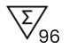 | Description
A |  | 1 Plate | Antigen coated 96-microwell plate. 12 x 8-well strips coated with purified human NTx antigen.
B |  | 0.4 mL vial | Antibody Conjugate Concentrate. Solution containing purified murine monoclonal antibody directed against NTx conjugated to horse radish peroxidase and Proclin™ 300 (0.1%). Supplied as a 100X concentrated conjugate.
C |  | 30 mL bottle | Antibody Conjugate Diluent. Buffered reagent with protein stabilizers, into which Antibody Conjugate Concentrate is diluted. ProClin™ 300 (0.05%) included as a preservative.
D |  | 125 mL bottle | 30X Wash Buffer Solution. One bottle containing a 30X ionic detergent solution.
E |  | 0.9 mL bottle | Chromogen Reagent. One vial containing a solution of 3,3’,5,5’ – tetramethylbenzidine in dimethyl-sulfoxide. Supplied as a 100x concentrate.
F |  | 30 mL bottle | Buffered Substrate. One bottle containing a buffered hydrogen peroxide solution.
G |  | 25 mL bottle | Stopping Reagent. One bottle containing a solution of 1N sulfuric acid.
1 |  | 0.4 mL vial | 1 nM BCE Calibrator | Various amounts of purified NTx antigen in a buffered diluent. Contains ProClin™ 300 (0.05%) as a preservative.
2 |  | 0.4 mL vial | 30 nM BCE Calibrator
3 |  | 0.4 mL vial | 100 nM BCE Calibrator
4 |  | 0.4 mL vial | 300 nM BCE Calibrator
5 |  | 0.4 mL vial | 1000 nM BCE Calibrator
6 |  | 0.4 mL vial | 3000 nM BCE Calibrator
I |  | 0.4 mL vial | Level I Urine Control | Human urine with known NTx concentration. ProClin™ 300 (0.10%) included as a preservative.
II |  | 0.4 mL vial | Level II Urine Control
 | Plate Sealers | 1 pad | Plate Sealers
NOTE: Note: Bovine Serum or Bovine Serum Albumin is present in some components.
MATERIALS REQUIRED BUT NOT PROVIDED
- Single and multichannel pipettes capable of delivering 25 μL, 100 μL and 200 μL volumes.
- Disposable pipette tips.
- Disposable plastic containers for reagent mixing and pipetting reservoirs.
- Automated microwell washer.
- Microwell or microstrip spectrophotometric reader. The reader must read at 450 nm with a 630 nm reference filter and detect absorbances from 0 to 3.000 (or greater) optical density units.
- Software capable of calculating a 4-parameter curve fit.
- Deionized water.
STORAGE CONDITIONS
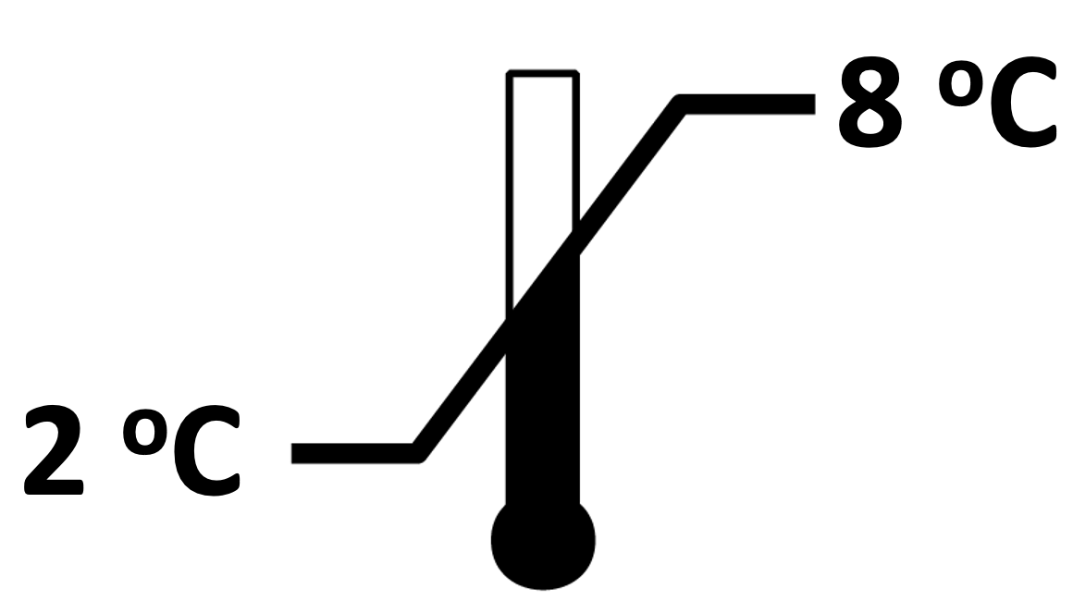 | When not in use, the kit should be stored at 2 – 8 °C. Reagents must be allowed to reach room temperature before use. Do not expose the reagents to temperatures greater than 30 °C or less than 2 °C.
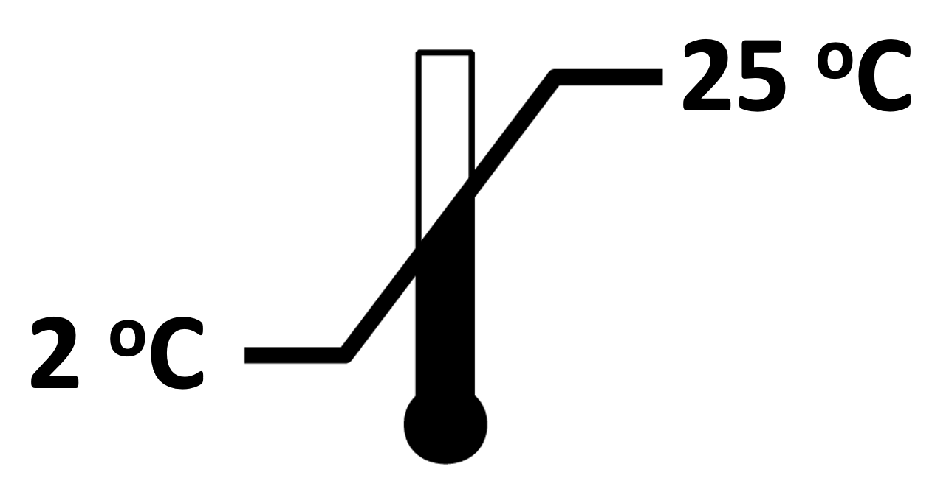 | Diluted (1X) wash solution may be stored at room temperature for up to one month.
PRECAUTIONS
- For in vitro diagnostic use only.
- The Antigen Coated 96-well Plate, Calibrators, and Urine Controls contain human urine and/or antigen processed from human bone tissue. Although each lot of urine and bone has been documented to be non-reactive for HIV 1, HIV 2, HBsAg, HCV and RPR by FDA approved methods, these materials should be handled as potentially infectious and should be disposed of properly.
- The Stopping Reagent contains 1N sulfuric acid. Danger: Causes severe skin burns and eye damage.
- The Chromogen Reagent contains 3,3',5,5'- tetramethylbenzidine and dimethylsulfoxide. Warning - Dimethylsulfoxide is readily absorbed through the skin. May cause skin irritation or serious eye irritation.
- ProClin is included as a preservative in most reagents, at concentrations listed in the reagent section. May cause skin irritation or serious eye irritation.
- Assay plate, Assay Calibrators, Urine Controls: Contain materials of human origin.
- Urine specimens may contain infectious agents and should be disposed of properly. Decontamination is most effectively accomplished with a 0.5% solution of sodium hypochlorite (1:10 dilution of household bleach) or by autoclaving one hour at 121 °C. Do not autoclave solutions containing sodium hypochlorite. Do not combine sodium hypochlorite solution with acid.
- Never pipette reagents or clinical specimens by mouth.
- Wear protective gloves and clothing when handling specimens and reagents. Wash hands thoroughly after use.
- Do not use reagents beyond their expiration dates.
- Do not mix components from different lots of the NTx Urine assay kits.
- Microwell strips must be kept desiccated. Reseal unused microwell strips in the pouch containing desiccant.
- Do not reuse microwells. Dispose of properly after use.
- Perform the assay procedure in a controlled laboratory environment that adheres to the stated incubation requirements. Avoid extreme environmental conditions during the procedure.

Note: Safety data sheets are available for professional users upon request.
SPECIMEN COLLECTION
- Collect a second void of the morning (spot) urine specimen or a 24-hour urine specimen in an appropriate collection device with a tight fitting lid.
- DO NOT ADD PRESERVATIVE TO URINE SPECIMEN.
- Specimens with visible whole blood contamination or visible hemolysis may interfere with the assay and should be discarded. Collection of a new specimen is recommended.
- Store refrigerated (2 – 8 °C) for up to 72 hours or at room temperature for up to 24 hours. Store frozen (–20 °C or below) for longer term storage. Specimens may undergo three freeze/thaw cycles.
- When monitoring therapy, baseline samples should be collected prior to initiation of therapy. Subsequent specimens for comparison should be collected at the same time of day as the baseline specimen.
ASSAY PROCEDURE
Preparatory Steps
- Allow all specimens and reagents to equilibrate to room temperature (18 – 28 °C) for at least one hour before performing the assay. To facilitate warming, remove reagents from the kit box. Frozen urine specimens may be thawed at 37 °C, in either a water bath or an incubator, then brought to room temperature prior to use in the assay. The Chromogen Reagent contains dimethylsulfoxide, which may solidify when refrigerated but is liquid at room temperature.
- Prepare the working strength wash solution. Dilute 30X Wash Concentrate 1:30 with deionized water (1 part 30X Wash Concentrate to 29 parts deionized water) and mix for a minimum of five (5) minutes. This solution is stable for one (1) month at room temperature.
- Create a plate map indicating location of calibrators, controls and urine specimens. It is recommended that calibrators, controls and urine specimens be run in duplicate microwells. An example of a plate map is provided below for a NTx Urine assay with 4 specimens:

 | 1 | 2 | 3
A | 1 nM BCE Calibrator | 1000 nM BCE Calibrator | Specimen #1
B | 1 nM BCE Calibrator | 1000 nM BCE Calibrator | Specimen #1
C | 30 nM BCE Calibrator | 3000 nM BCE Calibrator | Specimen #2
D | 30 nM BCE Calibrator | 3000 nM BCE Calibrator | Specimen #2
E | 100 nM BCE Calibrator | Level I Urine Control | Specimen #3
F | 100 nM BCE Calibrator | Level I Urine Control | Specimen #3
G | 300 nM BCE Calibrator | Level II Urine Control | Specimen #4
H | 300 nM BCE Calibrator | Level II Urine Control | Specimen #4

- Using a clean disposable plastic container, dilute the Antibody Conjugate Concentrate 1:101 using the Antibody Conjugate Diluent. As a guideline, for each Antigen Coated microwell strip used, dilute 20 μL Antibody Conjugate Concentrate into 2 mL of Antibody Conjugate Diluent. Mix gently by inversion only. Do not vortex or use a magnetic stir bar. Avoid foaming. Use the working strength conjugate solution within one hour of preparation. Do not reuse the container.
- Prior to pipetting, gently mix the Calibrators, Controls and urine specimens. Avoid foaming. Allow cloudy or turbid specimens to settle 5 to 10 minutes prior to pipetting. Urine specimens containing particulates may be centrifuged before use.
- Remove the appropriate number of microwell strips from the sealed foil pouch. Place any unused strips back in the pouch, resealing the pouch along the zipper. Do not remove the desiccant pillow from the foil pouch.

Specimen and Antibody Incubation
Once the assay has been started, complete it without interruption.
- Following the plate map generated in Step 3, pipette 25 μL of each Calibrator, Control, or urine specimen into the bottom of the designated microwells. Use a calibrated pipettor and new pipette tips for each Calibrator, Control, or urine specimen.
- Using a multichannel pipettor, deliver 200 μL of the working strength conjugate solution into each microwell. Apply a plate sealer and swirl the plate gently on a flat surface for 5-10 seconds to ensure mixing.
- Incubate the plate at room temperature (18 - 28 °C) for 90 ± 5 minutes.
- Prepare the Chromogen/Buffered Substrate solution during the last 10 minutes of incubation by making a 1:101 dilution of the Chromogen Reagent into the Buffered Substrate. As a guideline, for each Antigen Coated microwell strip used, dilute 20 μL of the Chromogen Reagent into 2 mL of the Buffered Substrate. Pipette the Buffered Substrate into a clean plastic disposable container. Thoroughly mix the Chromogen Reagent prior to pipetting. Add the Chromogen Reagent to the Buffered Substrate Reagent and invert gently to mix. Do not vortex, shake vigorously or use a magnetic stir bar to mix. Use the Chromogen/Buffered Substrate solution within 30 minutes of preparation. The Chromogen/Buffered Substrate solution should be colorless when mixed. A blue color indicates that the reagent has been contaminated and must be discarded. Do not reuse the Chromogen/Buffered Substrate solution container.
- At the end of the incubation period, carefully remove and discard the plate sealer. Wash the plate five (5) times with the working strength wash solution using an automated plate washer. The automated washer must dispense at least 350 μL of the working strength wash solution per well. Between wash cycles, wells should be filled with working strength wash solution. When wash procedure is complete, grasp the plate frame at the center of each side and invert, blotting on an absorbent paper towel. Immediately add the prepared Chromogen/Buffered Substrate solution as described below.

Color Development and Measurement
- Pipet 200 μL of the Chromogen/Buffered Substrate solution prepared in step 10 into each well using a multichannel pipettor. Cover the plate with a new plate sealer.
- Incubate at room temperature for 15 ± 1 minutes. A blue color will develop in wells containing bound antibody-horseradish peroxidase conjugate.
- Following incubation, carefully remove and discard the plate sealer. Using a multichannel pipettor, add 100 μL of Stopping Reagent to each well in the same order as addition of the Chromogen/Buffered Substrate Reagent. Wells which have developed a blue color will now turn yellow.
- Swirl the plate gently on a flat surface for 5 -10 seconds to ensure mixing. Allow the plate to sit at room temperature for 5 minutes before reading absorbance values.
- Within 30 minutes of adding the Stopping Reagent, read the absorbance of the Calibrators, Controls, and urine specimens. Use a microwell plate reader at 450 nm with a reference filter of 630 nm. The reader must have a maximum optical density reading of ≥3.

ANALYSIS OF RESULTS
- Determine concentration values (nM BCE) of Controls and urine specimens using a 4-parameter curve fitting equation.

EXAMPLE:
CALIBRATION CURVE
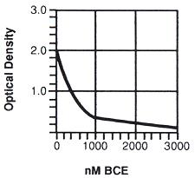

- Assay results are valid if the following criteria are met:
- The mean absorbance value of the 1 nM BCE Calibrator must be ≥1.500.
- The span of the calibrator curve (difference between absorbance values of the 1 nM BCE and 3000 nM BCE Calibrators) must be ≥1.300.
- The recommended coefficient of variation (% CV) between urine specimen concentration value (nM BCE) duplicates is ≤20%. Specimens with >20% CV should be rerun.
- The lower limit of detection is 20 nM BCE (assay value, does not include creatinine correction).
- Urine specimens that exceed 3000 nM BCE may be diluted 1:5 in a urine specimen or pool of urine known to be within the range of 200-500 nM BCE, and retested. When using urine as a diluent, the nM BCE of the urine diluent should be confirmed by testing it as a specimen in the same plate as the diluted unknown specimen. The dilution factor and background (the diluent nM BCE) should be incorporated into the final calculation.

Example: 1040 nM BCE assay value derived from a 1:5 dilution of a 4000 nM BCE specimen using a urine diluent of known NTx Urine assay value (300 nM BCE)

1040 nM BCE - (0.8 x 300 nM BCE) = 800 nM BCE
800 nM BCE x 5 (dilution factor) = 4000 nM BCE

Note: 1:5 dilutions represent 80% diluent (0.8), 20% specimen contribution.

6. Report the concentration values for urine specimens as nM BCE/mM creatinine, as shown in the following example:
Assay value = 360 nM BCE
Urinary creatinine = 60 mg/dL creatinine
11.3*
= 5.3 mM creatinine
360 nM BCE = 68 nM BCE/mM creatinine
5.3 mM creatinine

*Note: Conversion factor used to convert mg creatinine per dL to millimole creatinine per liter.

7. These Urine Control ranges have been established by the manufacturer. It is recommended that each laboratory establish its own control ranges.
LIMITATIONS OF THE PROCEDURE
While the NTx Urine assay is used as an indicator of bone resorption, the use of this test has not been established to predict development of osteoporosis or future fracture risk. Use of this test has not been established in primary hyperparathyroidism or hyperthyroidism. When using the NTx Urine assay to monitor therapy, results may be confounded in patients afflicted with clinical conditions known to affect bone resorption, e.g., metastases to bone. While a NTx Urine assay value provides a measure of the level of bone resorption, a single NTx Urine assay value cannot provide the rate of bone resorption as reported results do not contain a measure of time. The NTx Urine assay results should be interpreted in conjunction with clinical findings and other diagnostic results.
various rheumatic disorders.

REFERENCES
- Shetty S, Kapoor N, Bondu JD, Thomas N, Paul TV. Bone turnover markers: Emerging tool in the management of osteoporosis. Indian J Endocrinol Metab. 2016 Nov-Dec;20(6):846-852. doi: 10.4103/2230-8210.192914. PMID: 27867890; PMCID: PMC5105571.
- Greenblatt MB, Tsai JN, Wein MN. Bone Turnover Markers in the Diagnosis and Monitoring of Metabolic Bone Disease. Clin Chem. 2017 Feb;63(2):464-474. doi: 10.1373/clinchem.2016.259085. Epub 2016 Dec 9. PMID: 27940448; PMCID: PMC5549920.

- Jain S, Camacho P. Use of bone turnover markers in the management of osteoporosis. Curr Opin Endocrinol Diabetes Obes. 2018 Dec;25(6):366-372. doi: 10.1097/MED.0000000000000446. PMID: 30299435.

GLOSSARY OF SYMBOLS
The following symbols may have been used in the labelling of this product or products associated with this product.
For US Customer Service contact your local distributor.
For US Technical Support contact ZEUS Scientific, call toll free or e-mail support@zeusscientific.com.
For Customer Service and Technical Support inquiries outside the US, please contact your local Sebia subsidiary or authorized distributor.
©2025 ZEUS Scientific All Rights Reserved.
Symbol | Description | Symbol | Description
 | Manufacturer |  | Keep away from sunlight
 | In vitro diagnostic medical device |  | Plate
 | Catalogue number |  | Conjugate
n | Sufficient for n tests |  | Stopping Reagent
 | Batch code |  | Made in the USA
 | Use by |  | Wash Buffer Concentrate (30X)
 | Temperature limitation |  | Level I Control
 | Contents |  | Level II Control
 | Unique Device Identifier |  | Chromogen Reagent
 | Consult the warnings and precautions |  | Conjugate Diluent
 | Consult electronic instructions for use |  | Buffered Substrate
 | Store in the upright position |  | 1 nM BCE Calibrator
 | Applicable for U.S.A: Prescription in vitro diagnostic product |  | 30 nM BCE Calibrator
 | Corrosive |  | 100 nM BCE Calibrator
 | Hazardous Communication |  | 300 nM BCE Calibrator
 | English |  | 1000 nM BCE Calibrator
 |  |  | 3000 nM BCE Calibrator



ZEUS Scientific
200 Evans Way, Branchburg, New Jersey, 08876, USA
Toll Free (U.S.): 1-800-286-2111, Option 2
International: +1 908-526-3744
Fax: +1 908-526-2058
Website: www.zeusscientific.com

