Rapid SARS-CoV-2 IgM/IgG Test System
IVD
POC7801
REF

Institute Name | Date

PRINCIPLE OF THE ASSAY
This product utilizes a colloidal gold immunoassay technology. The assay cassette contains a pad impregnated with a colloidal gold-labeled recombinant SARS-CoV-2 antigen as well as colloidal gold labeled control antibody. The cassette membrane is printed with two test lines (one for IgG [G] and one for IgM [M]) as well as a control line (C). The M-line is printed with a mouse anti-human IgM monoclonal antibody, which is used to detect novel coronavirus IgM antibody. The G-line is printed with mouse anti-human IgG monoclonal antibody, which is used to detect novel coronavirus IgG antibody. The C-line (Control Line) is printed with quality control antibodies to verify proper performance of the reagents.

When the human blood sample is added to the sample well of the test card, the sample will flow along the test membrane using capillary action. If the sample contains IgM antibody directed against the virus, the IgM antibody binds to the gold-labeled recombinant antigen. This immune complex (IgM antibody + labeled antigen) will be captured by the anti-human IgM monoclonal antibody at the M line (#1 line), showing a purplish red M line, indicating that the person had IgM antibody for the novel coronavirus. If the sample contains IgG antibody directed against the virus, the IgG antibody binds to the gold-labeled recombinant antigen. This immune complex (IgG antibody + labeled antigen) will be captured by the anti-human IgG monoclonal antibody at the G line (#2 line), showing a purplish red G line, indicating that the person had IgG antibody for the novel coronavirus. If the person did not have IgG or IgM antibody to the virus, there will be no visible M line or G line, indicating that the person is negative for antibody to SARS-CoV-2. Finally, the membrane also contains a control line C. At line C, a visible control line should appear regardless of whether the patient possesses IgG or IgM antibody to the virus (whether or not a visible line forms at line M or line G). If the control line C does not appear, it indicates that the test result is invalid, and the sample should be tested again.

TEST SYSTEM COMPONENTS
Materials Provided:
Each Test System contains the following components in sufficient quantities to perform the number of tests indicated on the packaging label. NOTE: Test System also contains Instructions for Use.

SARS-CoV-2 Test Cassettes | 1. | Test Cassette: lateral flow immunoassay device configured with colloidal gold-labeled, recombinant SARS-CoV-2 antigen. Packaged in a poly-foil pouch with desiccant.
Specimen Diluent | 2. | Specimen Diluent: A phosphate-buffered-saline solution. Vial with white cap containing 450µL per vial. Ready to use.

PRECAUTIONS
- For in vitro diagnostic use only.
- Follow normal precautions exercised in handling laboratory reagents. In case of contact with eyes, rinse immediately with plenty of water and seek medical advice. Wear suitable protective clothing, gloves, and eye/face protection. Do not breathe vapor. Dispose of waste observing all local, state, and federal laws.
- The membrane of the Test Cassette does not contain viable organisms. However, consider the device potentially biohazardous materials and handle accordingly.
- The Test Cassette should remain in the sealed pouch until use.
- Optimal assay performance requires strict adherence to the assay procedure outlined in this product insert. Any deviation from this assay procedure may lead to aberrant results. Adherence to the specified time and temperature of incubations is essential for accurate results. All reagents must be allowed to reach room temperature (20 - 25°C) before starting the assay.
- Dilution or adulteration of these reagents may generate erroneous results.
- Do not use reagents from other sources or manufacturers.
- Never pipette by mouth. Avoid contact of reagents and patient specimens with skin and mucous membranes.
- Avoid microbial contamination of reagents. Incorrect results may occur.
- Cross contamination of reagents and/or samples could cause erroneous results.
- Avoid splashing or generation of aerosols.
- Do not expose reagents to strong light during storage or incubation.
- Allowing the Test Cassette to equilibrate to room temperature prior to opening the protective envelope will protect the wells from condensation.
- Do not expose any of the reactive reagents to bleach-containing solutions or to any strong odors from bleach-containing solutions. Trace amounts of bleach (sodium hypochlorite) may destroy the biological activity of many of the reactive reagents within this Test System.
- The Lancet, Capillary Dispenser and/or Test Cassette should be discarded in a proper biohazard container after use.

MATERIALS REQUIRED BUT NOT PROVIDED
- Laboratory timer to monitor the incubation step.
- Alcohol wipe.
- Sterile gauze or similar wipe.
- Lancet.
- 65µL pipette or equivalent dispenser.
- Small adhesive bandages.
- Sharps container.
- Biohazardous waste container.

STORAGE CONDITIONS
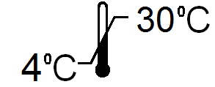 | Test Cassette: 4 - 30°C, do not place in direct sunlight.  Specimen Diluent: 4 - 30°C.  DO NOT FREEZE. Do not use beyond the printed Expiration Date.  Once opened, the test cassette must be used within 20 minutes or discarded.

SPECIMEN COLLECTION
- ZEUS Scientific recommends that the user carry out specimen collection in accordance with CLSI document M29: Protection of Laboratory Workers from Infectious Disease (Current Edition). No known test method can offer complete assurance that human blood samples will not transmit infection. Therefore, consider all blood derivatives potentially infectious.
- If using human serum, store sample at room temperature for no longer than 8 hours. If testing is not performed within eight hours, sera may be stored between 2 - 8°C, for no longer than 48 hours. If a delay in testing is anticipated, store test sera at –20°C or lower. Avoid multiple freeze/thaw cycles which may cause loss of antibody activity and give erroneous results. It is the responsibility of the individual laboratory to use all available references and/or its own studies to determine stability criteria for its laboratory (3). Use only freshly drawn and properly refrigerated sera obtained by approved aseptic venipuncture procedures in this assay (1,2). Do not use if there are any added anticoagulants or preservatives. Avoid using hemolyzed, lipemic, or bacterially contaminated sera.
- Capillary blood may be collected and utilized as outlined in the procedure below. Capillary blood must be used immediately and cannot be stored for use later.
- Venous whole blood (EDTA) may be collected using approved protocols and used within four hours of collection.

ASSAY PROCEDURE
- The ZEUS Rapid SARS-CoV-2 IgM/IgG Test Cassette contains the following features:
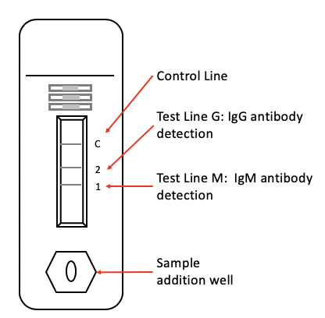
- Read the instructions carefully before beginning.
- Allow the Test Cassette and Specimen Diluent to equilibrate to room temperature (15 - 30°C) before use. Do NOT warm these components to speed the process.
- Obtain the venuous blood, capillary blood, serum or plasma using standard protocols.
- Open the pouch and remove the Test Cassette. Place it on a clean and level surface. Discard the pouch and the desiccant.
- Using a calibrated pipette, add 65µL of blood, serum or plasma to a tube containing 450µL of the Specimen Diluent.
- Mix the contents of the tube by gently inverting the tube repeatedly.
- Transfer 65µL of the diluted specimen to the sample addition well of the test cassette.
- Set a laboratory timer.
- Read the results within 15 minutes.
- After 18 minutes, the results are invalid.

INTERPRETATION OF RESULTS
When the 15 minute incubation has been completed, results may be interpreted as follows:
- Possible Anti-SARS-CoV-2 Positive Result:
  - A visible M-line (#1 line) in conjunction with a visible C-line. This indicates that the patient has IgM antibody to the SARS-CoV-2 virus.
  - A visible G-line (#2 line) in conjunction with a visible C-line. This indicates that the patient has IgG antibody to the SARS-CoV-2 virus.
  - A visible M-line and a visible G-line in conjunction with a visible C-line. This indicates that the patient has both IgM and IgG antibody to the SARS-CoV-2 virus.
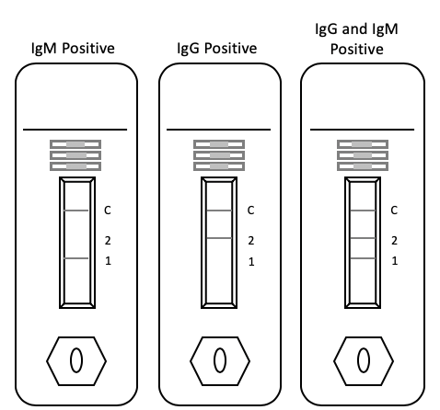
Figure 1: Sample IgM Positive, IgG Positive and IgM + IgG Positive Reactions
- Anti-SARS-CoV-2 Negative Result:
If there is no visible M-line (#1 line) and no visible G-line (#2 line); however, there is a visible C-line. That means the test is valid; however, the patient did not have any detectable IgM or IgG antibody to the SARS-CoV-2 virus. Negative results do not rule out SARS-CoV-2 infection, particularly in those who have been in contact with the virus. Follow up testing with a molecular diagnostic should be considered to rule out infection on these individuals. Figure 2 depicts a negative result.
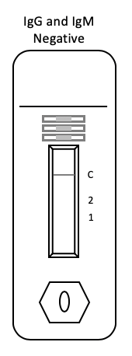
Figure 2: Negative Test Result Example

- Invalid Test Results: Regardless of the results of the M-line and the G-line (#1 line and #2 line), if there is no visible line at the C-line, the test is considered invalid and the test should be repeated. Examples of invalid test results are depicted in Figure 3 below.
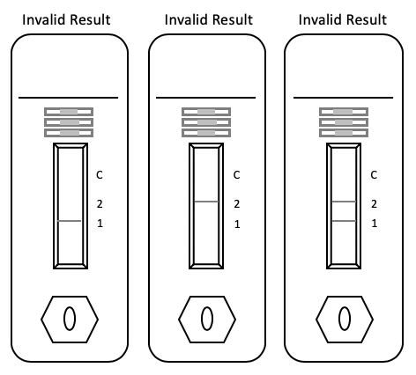
Figure 3: Invalid Test Result Examples
- When reporting test results, please consider the following:
  - This test has not been reviewed by FDA
  - Negative results do not rule out SARS-CoV-2 infection, particularly in those who have been in recent contact with the virus. Follow up testing with a molecular diagnostic should be considered to rule out nfection on these individuals.
  - Results from antibody testing should not be used as the sole basis to diagnose or exclude SARS-CoV-2 infection or to inform infection status.
  - Positive results may be due to past or present infection with non-SARS-CoV-2 coronavirus strains, such as coronavirus HKU1, NL63, OC43 or 229E.

QUALITY CONTROL
- A procedural control is included within the Test Cassette. A visible/obvious line appearing in the Control Line area of the Test Cassette confirms that the specimen volume was adequate, the reagents performed properly and the technique was acceptable.
- Technicians should observe a relatively clear background. If there is an excessive amount of background or odd reactions in areas other than the Control or Test Line areas, the results may be questionable and should be repeated.
- Human control standards are not included with this kit; however, it is recommended that positive and negative human controls be tested as a good laboratory practice to confirm the test procedure and to verify the proper test performance.

LIMITATIONS OF THE ASSAY
- Samples collected too early in the course of an infection may not have detectable levels of IgM or IgG.
- The results of this test are qualitative, considered them as either positive or negative for the presence of anti-SARS-CoV-2 antibodies. The intensity of the line has no bearing on the concentration of antibody present.
- Samples with excessive hemolysis, lipids, or bacterial contanimation should be avoided. False results may occur.

REFERENCES
- Procedures for the Handling and Processing of Blood Specimens. NCCLS Document H18-A, Vol. 10, No. 12, Approved Guideline, 1990.
- Procedures for the collection of diagnostic blood specimens by venipuncture. 2nd edition. Approved Standard (1984). Published by National Committee for clinical Laboratory Standards.
- Procedures for the Handling and Processing of Blood Specimens for Common Laboratory Tests; Approved Guidelines – 4th Edition (2010). CLSI Document GP44-A4 (ISBN 1-56238-724-3). Clinical and Laboratory Standards Institute, 950 West Valley Road, Suite 2500, Wayne, PA 19087.
In the US & Canada, call toll free, or e-mail Customer Service (orders@zeusscientific.com) or Technical Service (support@zeusscientific.com).
For all other countries, please contact your local distributor.
©2020 ZEUS Scientific, Inc. All Rights Reserved.
ZEUS Scientific, Inc.
200 Evans Way, Branchburg, New Jersey, 08876, USA
Toll Free (U.S.): 1-800-286-2111, Option 2
International: +1 908-526-3744
Fax: +1 908-526-2058
Website: www.zeusscientific.com

